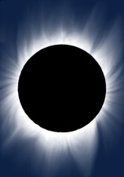

Photovoltaic (PV) and the Solar-powered House

Adapted from “Photovoltaic Cells: Converting Photons to Electrons”

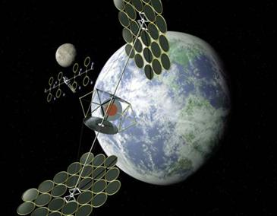

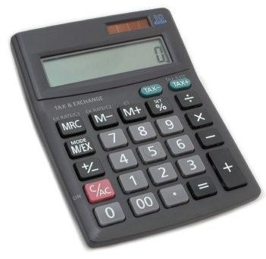 The solar cells that you’ve seen on calculators and satellites are called photovoltaic cells, or modules (modules are simply a group of cells electrically connected and packaged in one frame). Photovoltaics, as the word implies (photo = light, voltaic = electricity), convert sunlight directly into electricity. Once used almost exclusively in space, photovoltaics are used more and more in less exotic ways. They could even power your house.

How do these devices work? PV cells are made of special materials called semiconductors such as silicon, which is currently the most commonly used. Basically, when light strikes the cell, a certain portion of it is absorbed within the semiconductor material. This means that the energy of the absorbed light is transferred to the semiconductor. The energy knocks electrons loose, allowing them to flow freely. PV cells also have one or more electric fields that act to force electrons freed by light absorption to flow in a certain direction. The flow of electrons is a current, and by placing metal contacts on the top and bottom of the PV cell, we can draw that current off to use externally. For example, the current can power a calcuator. The current, together with the cell’s voltage defines the power that the solar cell can produce.

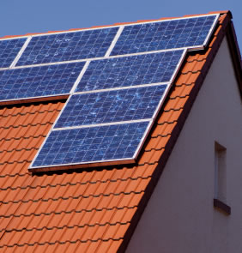 What would you need to do to power your house with solar energy? Although it’s not as simple as just slapping some modules on you roof, it’s not extrememly difficult to do, either.

First of all, not every roof has the correct orientation or angle of inclination to take advantage of the sun’s energy. Non-tracking PV systems in the Northern Hemisphere should point toward true south. They should be inclined at an angle equal to the area’s latitude to absorb the maximum amount of energy all year-round. A different orientation and/or inclination could be used if you want to maximize energy production for the morning or afternnon, and/or the summer or winter. Of course, the modules should never be shaded by nearby trees or buildings, no matter what the time of day or the time or year. In a PV module, even if just one of its 36 cells is shaded, power production will be reduced by more than half.

If you have a house with an unshaded, south-facing roof, you need to decide what size system you need. This is complicated by the facts that your electricity production depends on the weather (which is never completely predictable) and that your electricity demand will also vary. These hurdles are fairly easy to clear. Meteorological data gives average monthy sunlight levels for different geographical areas. This takes into account rainfall and cloudy days, as well as altitude, humidity, and other more subtle factors. You should design for the worst month, so that you’ll have enough electricity all year-round. With that data, and knowing your average household demand (your utility bill conveniently lets you know how much energy you use every month), there are simple methods you can use to determine just how many PV modules you’ll need. You’ll also need to decide on a system voltage, which you can control by deciding how many modules to wire in series.

You may have already guessed a couple of problems that we’ll have to solve. First, what do we do when the sun isn’t shining?

Certainly, people would not accept only having electricity during day, and then only on clear days, if they have a choice. We need energy storage – batteries. Unfortunately, batteries add a lot of cost and maintenance to the PV system. Currently, however, it’s a necessity if you want to be completely independent. One way around the problem is to connect your house to the utility grid, buying power when you need it and selling to them when you produce more than you need. This way, the utility acts as a practically infinite storage system. The utility company has to agree, or course, and in most cases will by power from you at a much lower price than their own selling price. You will also need special equipment to make sure that the power you sell to your utility is synchronous with theirs – that it shares the same sinusoidal waveform and frequency. Safety is an issuse as well. The utility company has to make sure that if there’s a power outage in your neighborhood, your PV system won’t try to feed electricity into lines that a lineman may think is dead. This is called islanding.

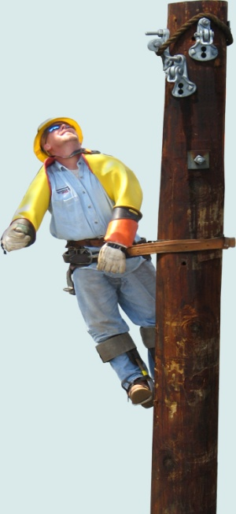 If you decide to use batteries, keep in mind that they will have to be maintained, and then replaced after a certain number of years. The PV modules should last 20 years or more, but batteries just don’t have that kind of useful life. Batteries in PV systems can also be very dangerous because of the energy they store and the acidic electrolytes they contain, so you’ll need a well-ventilated, non-metallic enclosure for them.

Although several different kinds of batteries are commonly used, the one characeristic they should all have in common is that they are “deep-cycle”. Unlike your car battery, which is a “shallow-cycle” battery, deep-cycle batteries can discharge more of their stored energy while still maintaining long life. Car batteries discharge a large current for a very short time – to start you car. Then they are immediately recharged as you drive. PV batteries, one the other hand, generally have to discharged a smaller current for a longer period (such as all night), while being charged during the day.

The most commonly used deep-cycle batteries are lead-acid batteries and nickel-cadmium batteries. Nickel-cadmium batteries are more expensive, but last longer and can be discharged more completely withough harm. Even deep-cycle lead-acid batteries can’t be discharged 100 percent without serioulsy shortening battery life. And generally, PV systems are designed to discharge lead-acid batteries no more than 40 or 50 percent.

Also, the use of batteries requires the installation of another component called a charge controller. Batteries last a lot longer if care is taken so that they aren’t overcharged or drained too much. That’s what a charge controller does. Once the batteries are fully charged, the charge controller doesn’t let current from the PV modules continue to flow into them. Similarly, once the batteries have been drained to a certain predetermined level, controlled by measuring battery voltage, many charge controllers will not allow more current to be drained from the batteries until they have been recharged. The use of a charge controller is essential for long battery life.

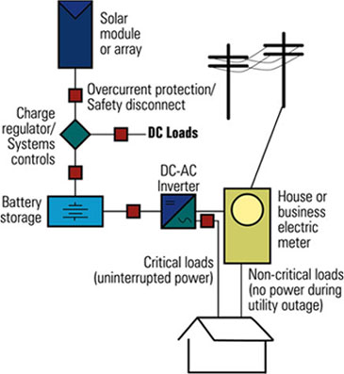 The other problem besides energy storage is that the electricity generated by your PV modules, and extracted from your batteries, if you choose to use them, is not in the form that’s used by the electrical appliances in your house. The electricity generated by a solar system is direct current, while the electricity supplied by your utility company (and the kind that every appliance in your house uses) is alternating current. You will need an inverter, a device that converts DC to AC. Most large inverters will also allow you to automaticlly control how your system works. Some PV modules, called AC modules, actually have an inverter already built into each module, eliminating the need for a large, central inverter, and simplifying wiring issues.

Throw in the mounting hardware, wiring, junction boxes, gounding equipment, overcurrent protection, DC and AC disconnects and other accessories, and you’ll have yourself a system. Electrical codes must be followed, and it’s highly recommended that the installation be done by a licensed electrician, who has experience with PV systems. Once installed, a PV system requires very little maintenance (especially if no batteries are used), and will provide electricity cleanly and quietly for 20 years or more.

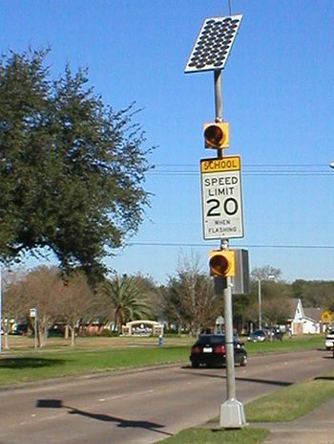 If photovoltaics are such a wonderful source of free energy, why doesn’t the whole world run on solar? You’ve probably seen calculators that have solar cells –calculators that never need batteries, and in some cases don’t even have an off button. As long as you have enough light, they seem to work forever. You may have seen larger solar panels – on emergency road signs or call boxes, on buoys, even in parking lots to power lights. Although these larger panels aren’t as common as solar powered calculators, they’re out there and not that hard to spot if you know where to look.

